# Software Installation

## VirtualBox Ubuntu 20.04

### Downloading the VirtualBox Ubuntu Image

Navigate to <https://www.osboxes.org/ubuntu/> and download the Ubuntu 20.04 image for VirtualBox:

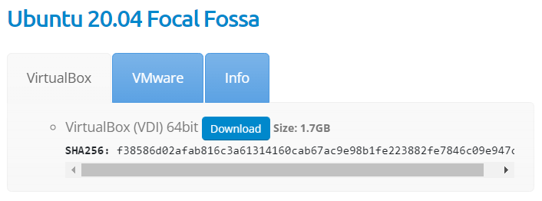

Figure 1: Ubuntu VirtualBox image

### Installing 7-Zip

The downloaded file Ubuntu-20.04-VB-64bit is a 7-Zip archive containing the Ubuntu VirtualBox image. 7- Zip will need to be installed to extract the image. If you already have 7-Zip installed, skip to the next section: *Extracting the Ubuntu Image*.

Navigate to <https://www.7-zip.org/> and download the 7-Zip installer:

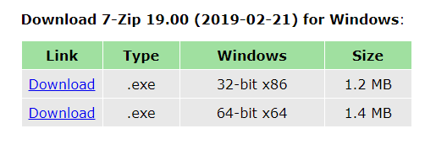

Figure 2: 7-Zip installer download

Run the downloaded .exe and follow the prompts to install 7-Zip.

### Extracting the Ubuntu Image

With 7-Zip installed, right click on Ubuntu-20.04-VB-64bit.7z from the downloads within Windows Explorer and select 7-Zip –> Extract Files:

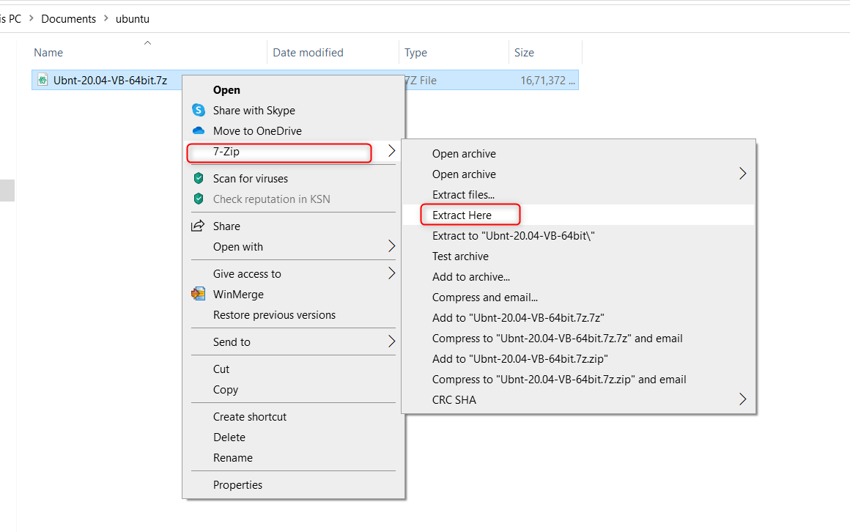

Figure 3:To extract the vdi files

Create a path in the D drive to store the VDI file and add the path from drop down menu or from the tab (), in this case the path is D:\Innophase\VirtualBox VMs

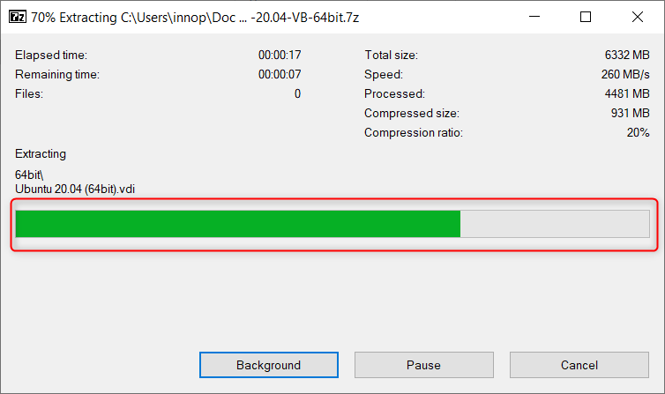

Figure 4: Extracting the Ubuntu VirtualBox image to D drive path

This will create a folder containing Ubuntu 20.04 (64bit), the Ubuntu 20.04 VirtualBox disk image (VDI) file.

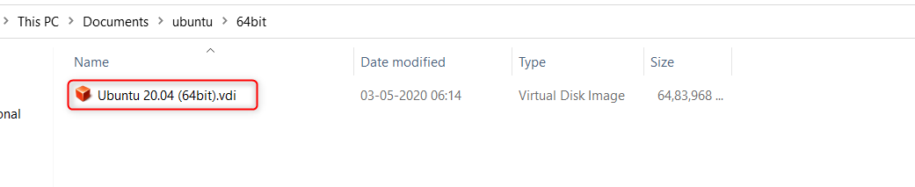

Figure 5: Extracted VDI file

### Installing VirtualBox

1. Navigate to <https://www.virtualbox.org/wiki/Downloads> and download VirtualBox 6.1.18 for Windows hosts:

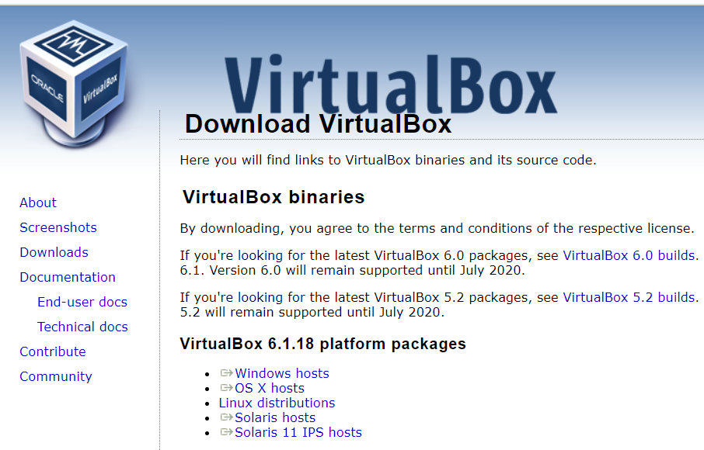

Figure 6: VirtualBox binary download

1. Run the downloaded.exe and follow the prompts to install VirtualBox. Ensure VirtualBox USB Support is selected (this is the default).

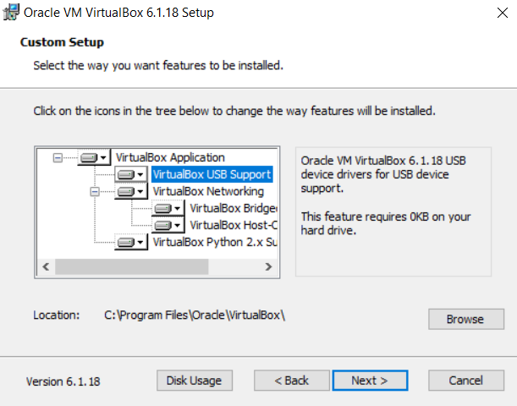

Figure 7: Leave VirtualBox USB Support enabled

1. Follow the rest of the prompts to complete installation.

### Setting up the Virtual Machine

1. Launch VirtualBox, and you will be presented with the VirtualBox Manager. Click New to create a new virtual machine

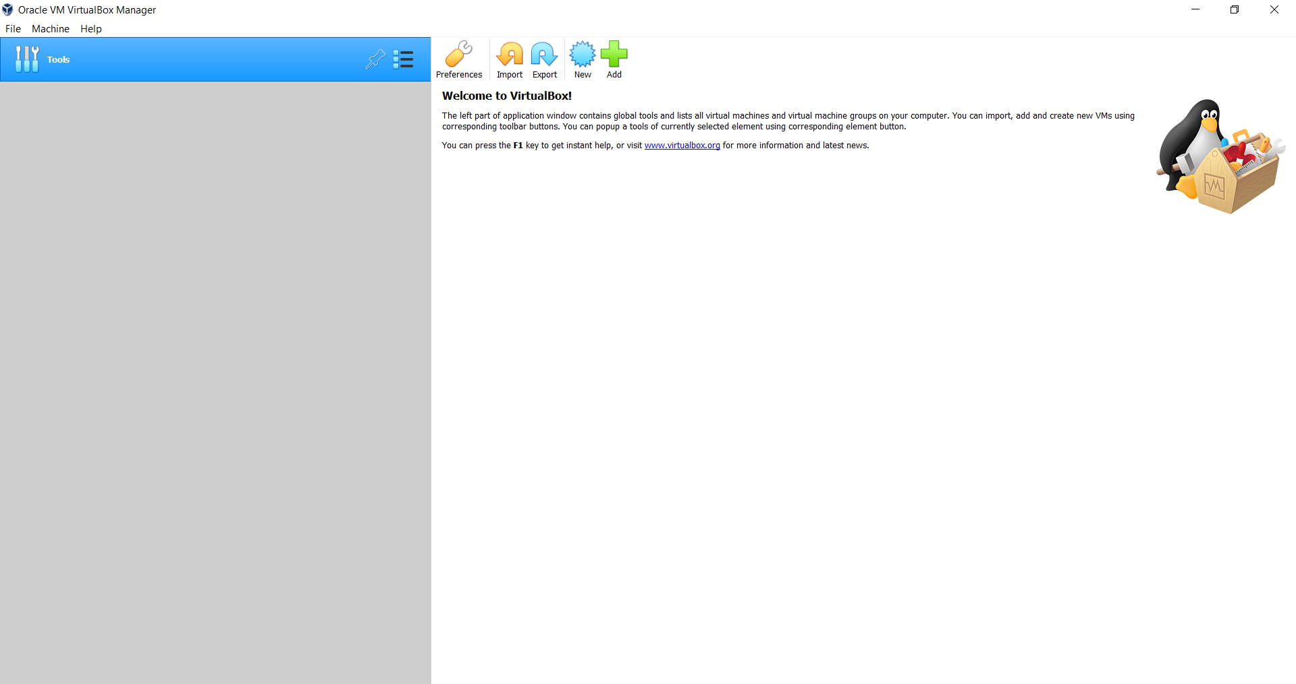

Figure 8: The VirtualBox Manager

1. Give the virtual machine a descriptive name, for example, Ubuntu 20.04. Verify that VirtualBox has picked up the correct Type and Version for the virtual machine and click Next.

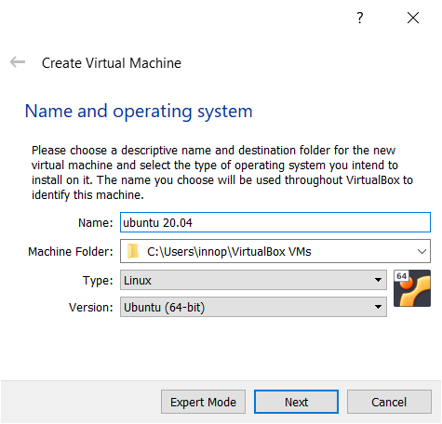

Figure 9: Creating a new virtual machine

1. You will now be prompted to allocate memory to the virtual machine. Provide at least 4GB for smooth operation and press Next

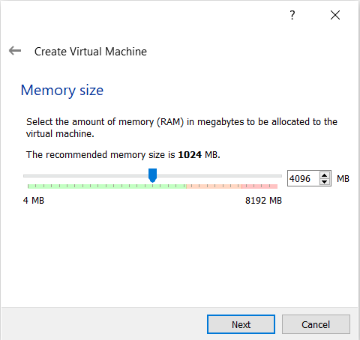

Figure 10: Virtual machine memory allocation

1. Before proceeding with virtual machine creation, see if the Ubuntu 20.04 VirtualBox disk image (VDI) file into the appropriate VirtualBox VM folder that has been created. Open a Windows Explorer window, type the following into the address bar, and press Enter

|  |
| --- |
| %HOMEPATH%\VirtualBox VMs\64bit\Ubuntu 20.04 (64bit) |

**Note:** %HOMEPATH% is the path of the newly created VDI path of D drive.

1. Return to the virtual machine creation wizard using the Windows taskbar. When prompted to add a virtual hard disk, select Use an existing virtual hard disk file and click on the folder icon.

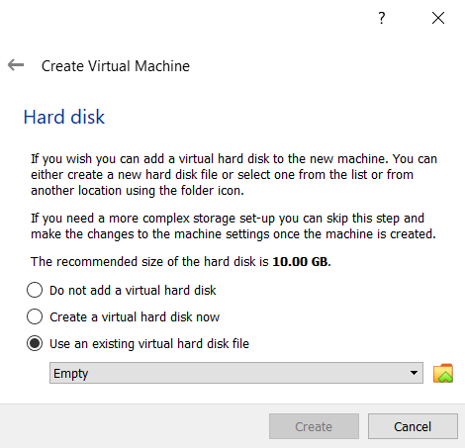

Figure 11: Virtual machine hard disk selection

1. In the dialog that appears, click the Add button.

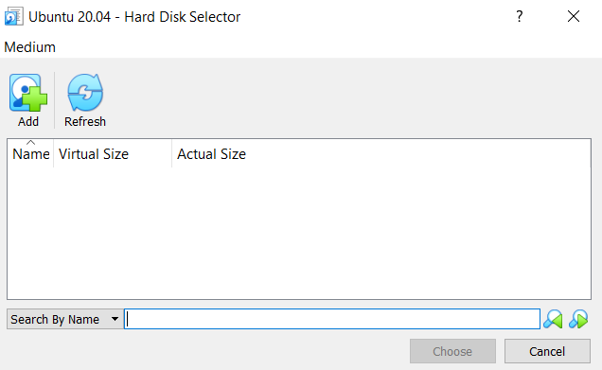

Figure 12: Adding an existing virtual hard disk

1. Navigate to the VDI file you just moved and select it.

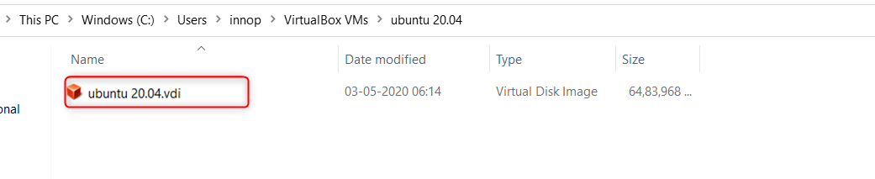

Figure 13: Selecting the existing virtual hard disk

1. Accept this virtual hard disk as the disk for the virtual machine in the dialog boxes.
2. Press Create to create the virtual machine. Once the virtual machine has been created, start it from the VirtualBox Manager by pressing the Start button.

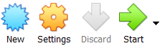

Figure 14: Press the Start button to start the virtual machine

1. The virtual machine should now start. If it does not, you may be presented with an error saying that VT-x or AMD-V is disabled in the BIOS.

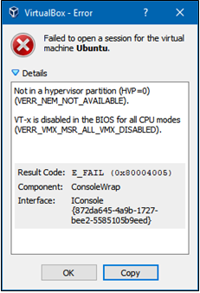

Figure 15: Error message reporting that VT-x is disabled

1. Hardware virtualization (VT-x / AMD-V) is required to run a 64-bit guest in VirtualBox and you will therefore be required to enable it from within the BIOS settings of your computer. The procedure for doing this varies from computer to computer, so detailed instructions are not supplied here. However, the general procedure involves rebooting your computer and pressing a key before Windows boots to access the BIOS settings menu. Once in the BIOS settings menu, enable hardware virtualization and boot into Windows. Open the VirtualBox Manager and try to start the virtual machine again.
2. When the virtual machine starts, login with the following when prompted:
   1. Username: osboxes.org
   2. Password: osboxes.org

### Installing Guest Additions

1. From the virtual machine menu, select Devices –> Insert Guest Additions CD image

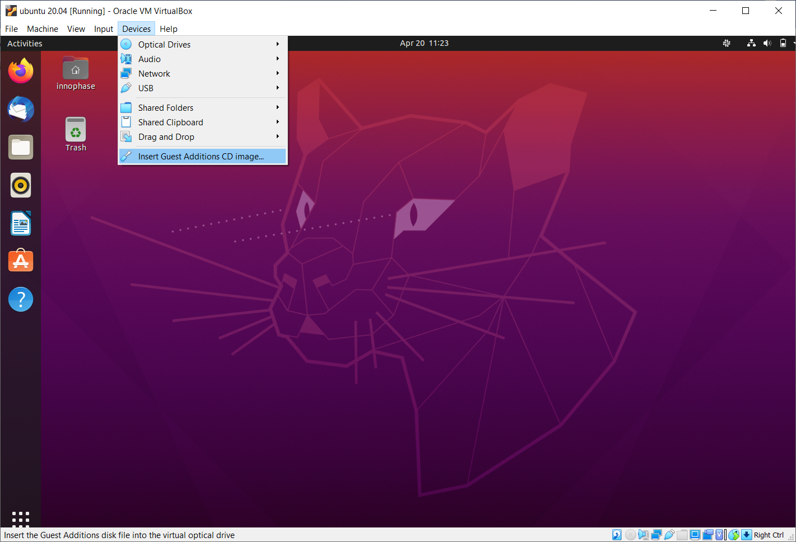

Figure 16: Inserting the guest additions CD

When prompted, select Run to run the software from the Guest Additions CD. Allow the Guest Additions software to install, entering the password osboxes.org and following any prompts as required. After the install has completed, eject the Guest Additions CD from the desktop and reboot the virtual machine.

### Enabling Shared Clipboard

1. From the virtual machine menu, select Devices –> Shared Clipboard –> Bidirectional

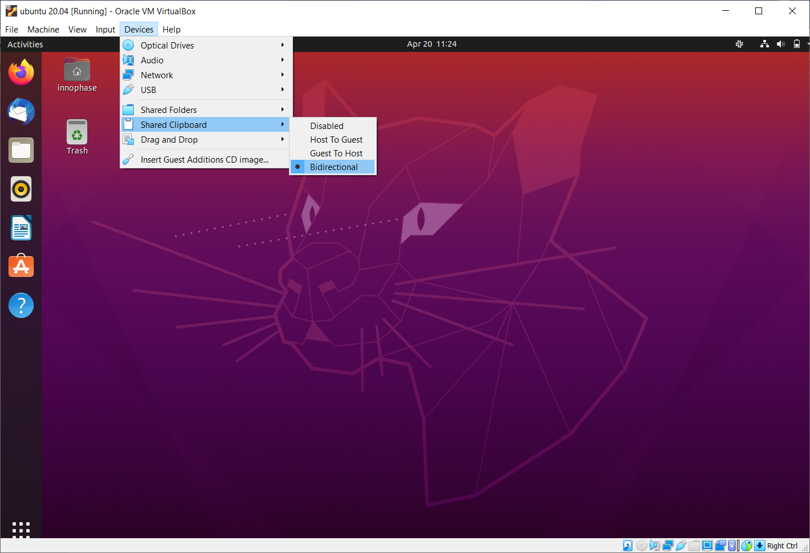

Figure 17: Virtual machine shared clipboard

It will now be possible to copy and paste text between the host (Windows) and the guest (Ubuntu).

### Opening a Terminal

1. Further steps in this guide will require you to open a terminal window in Ubuntu. Right click from any location in Files, the graphical filesystem explorer, and select Open in Terminal

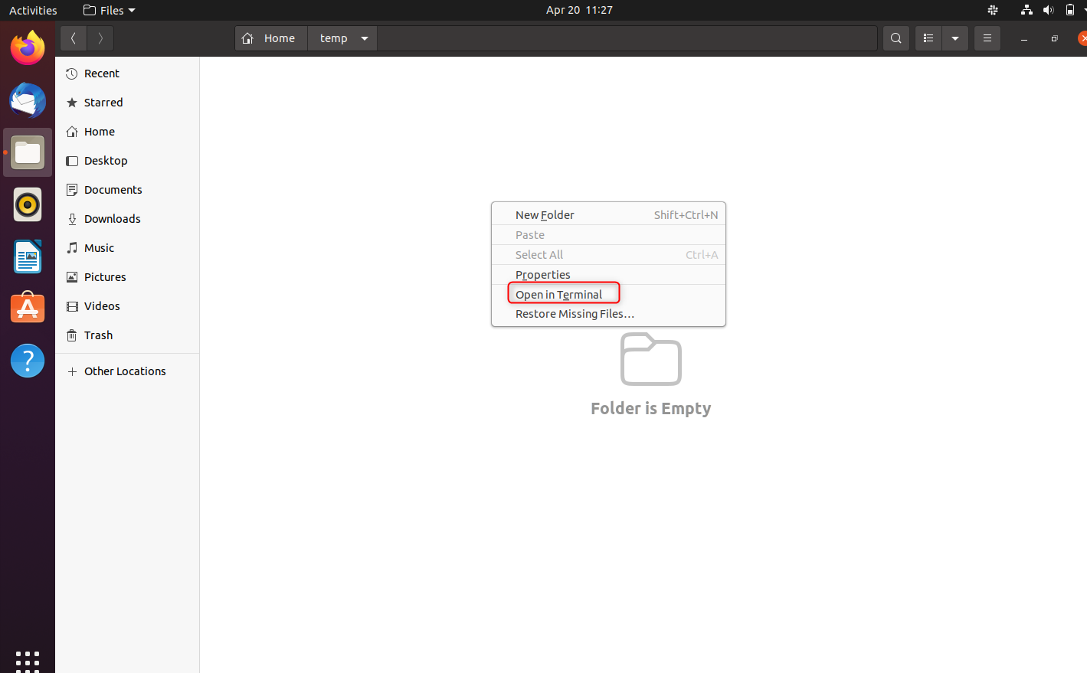

Figure 18: Opening a terminal in Ubuntu

This will open a terminal window in that directory in which commands can be typed.

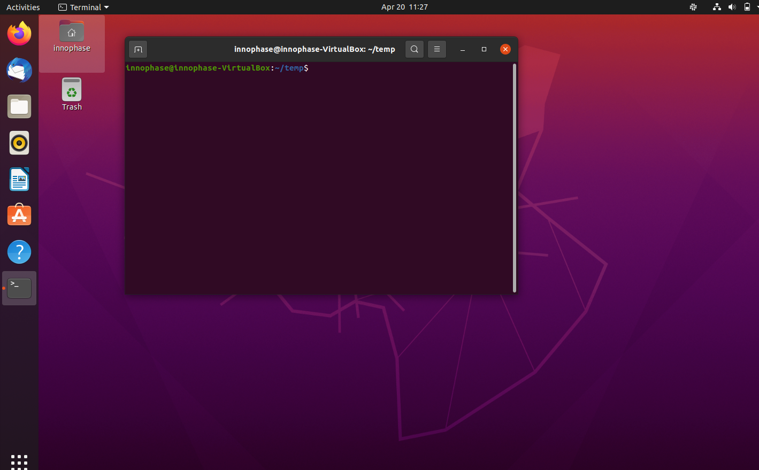

Figure 19: A terminal window

### Installing Necessary Packages

In any terminal window, execute the following commands, enter the password which was used for the creation in section: *Setting up the Virtual Machine*, point 12.

|  |
| --- |
| sudo apt update  sudo apt install build-essential libc6-armel-cross libc6-dev-armel-cross binutils-arm-linux-gnueabi libncurses5-dev -y |

### Downloading the ARM Toolchain

1. From within a directory of your choice, execute the following command in a terminal window to download the ARM toolchain archive

|  |
| --- |
| wget https://developer.arm.com/-/media/Files/downloads/gnu-rm/10.3-2021.10/gcc-arm-none-eabi-10.3-2021.10-x86_64-linux.tar.bz2 |

1. Execute the following command to extract the toolchain from the archive

|  |
| --- |
| tar xvf gcc-arm-none-eabi-10.3-2021.10-x86_64-linux.tar.bz2 |

1. Execute the following command to move the toolchain to the common usr folder, enter the password as prompted

|  |
| --- |
| sudo mv gcc-arm-none-eabi-10.3-2021.10 /usr/ |

**Note**: The following two steps (step 4and 5) and should be followed **only** while using a virtual machine and **must be skipped** while using the standalone OS.

1. Execute the following commands to set up the toolchain path

|  |
| --- |
| echo >> ~/.profile  echo 'export PATH=/usr/ gcc-arm-none-eabi-10.3-2021.10/bin:$PATH' >> ~/.profile |

1. Reboot the virtual machine so that the changes to PATH are applied

### Installing Python3 and dependencies

In any terminal window, execute the following commands to install Python3 and other Python packages that will be needed. Enter the password as prompted

|  |
| --- |
| sudo apt install python3 -y  sudo apt install python3-pip -y  pip3 install pyelftools pyserial pyusb pyftdi ecdsa pycryptodome |

### Installing OpenOCD

In any terminal window, execute the following command to install OpenOCD. Enter the password as prompted

|  |
| --- |
| sudo apt install openocd -y |

### Downloading and Compiling the InnoPhase SDK

*Check with your InnoPhase support team to obtain the latest version of the SDK*.

Download the SDK zip file in the Ubuntu virtual machine. Open a terminal in the directory in which you downloaded the SDK and execute the following commands:

|  |
| --- |
| unzip sdk<version>.zip (Example: unzip sdk_2.3.zip)  cd sdk/apps/  make |

This will create an ELF file for each of the applications shared with the SDK.

### Setting Execute Permissions for SDK Scripts

This step ensures that the file permissions for the Python scripts in the SDK are set to allow for execution. To accomplish this, open a terminal in the SDK directory and execute the following command:

|  |
| --- |
| cd ..  chmod -R u+x ./script/*.py |

### Connecting the EVK board

1. Connect the EVK board to the PC using the provided Micro USB cable. Transfer port access rights to the Ubuntu virtual machine. From the virtual machine menu select Devices –> USB -> InnoPhase EVB[0800] or FTDI InnoPhase T2 Evaluation Board [0800].

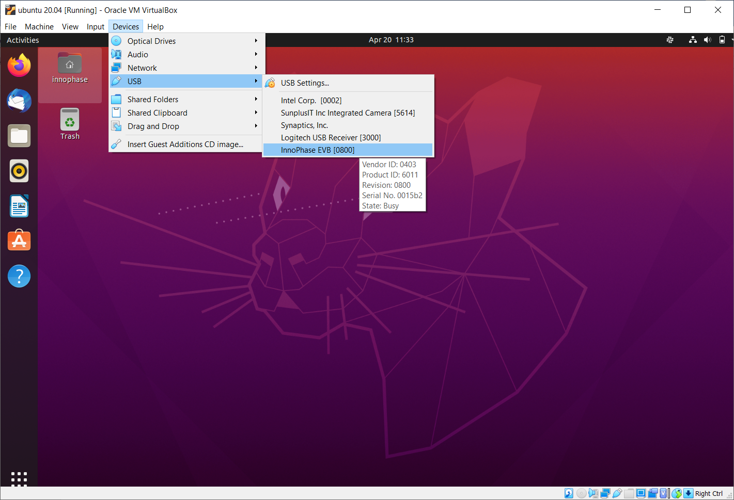

Figure 20: Transferring port access rights to the Ubuntu virtual machine

1. In any terminal window, execute the following commands to ensure Ubuntu recognizes the EVK board

|  |
| --- |
| lsusb |

The following USB device should be listed in the output:

Figure 21: Verifying that Ubuntu recognizes the EVK board

To ensure atleast four USB serial devices are listed, execute the following command:

|  |
| --- |
| ls /dev/ttyUSB* |

At least four USB serial devices should be listed:

Figure 22: USB serial devices

**Note:** This output should contain 4 entries. In some cases, the entries could be different - /dev/ttyUSBX, where X is not between 1-4 (Eg.: /dev/ttyUSB5 instead of /dev/ttyUSB4), which is acceptable

### Opening the Console

In any terminal window, execute the following command to open a CONSOLE to Talaria TWO

|  |
| --- |
| sudo apt install python3-serial  miniterm /dev/ttyUSB3 2457600 |

The connection should be established without errors.



Figure 23: Establishment of a CONSOLE to the T2

Hardware setup is now complete.

### Download and Test Provided Sample Application

With the software and hardware setup complete, you are now ready to download an application to Talaria TWO. Before following these steps, ensure that you have a CONSOLE open to Talaria TWO, as described in the section: *Installing Guest Additions*.

1. Press the Reset button on the EVK board. Open a terminal in the SDK directory and browse through the path "/SDK_x.y/". , then execute the following commands:

**Load the flash helper**:

|  |
| --- |
| ./script/boot.py --device /dev/ttyUSB2 --reset=evk42_bl ./apps/gordon/bin/gordon.elf |

Expected output:

Figure 24: Load the flash helper

**Invalidate the boot image**:

|  |
| --- |
| dd if=/dev/zero of=./empty.img bs=1K count=1 |

Expected output:

Figure 25: Invalidate the boot image

**Clear the flash**:

|  |
| --- |
| ./script/flash.py --device /dev/ttyUSB2 write 0x1000 ./empty.img |

Expected output:

Figure 26: Clear flash

**Program the application**:

|  |
| --- |
| ./script/boot.py --device /dev/ttyUSB2 --reset=evk42 binaries/product/at/bin/t2_atcmds.elf hio.transport=0 |

Expected output:

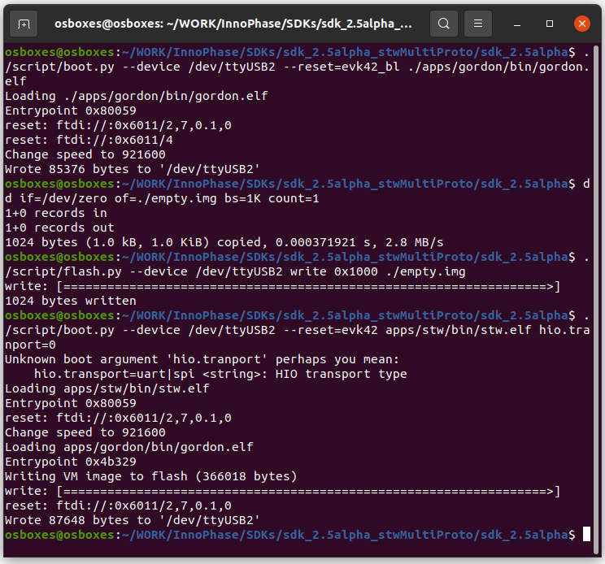

Figure 27: Program the application

**Note**:

* 1. Place the --reset=evk42 before the target elf file path.
  2. hio.transport=<value> is the interface type for command link.

where, <value> can be one of the following:

0: UART

1: SPI

Expected output:

Figure 28: Downloading the Serial to Wi-Fi application

Console output:

Figure 29: CONSOLE output when downloading the Serial to Wi-Fi application

1. From within your terminal window, start the host side script to interact with Talaria TWO by executing the following command:

|  |
| --- |
| ./script/talaria_cli.py /dev/ttyUSB2 |

1. You will be presented with a list of commands and a dropped into a CLI prompt. Type create and press Enter.

Figure 30: Execution of the CLI application on the host

Console output:

**Note**: Console output can vary between SDK releases

Figure 31: CONSOLE output when executing the "create" command

A Wi-Fi interface has been created. Now, other commands available in the CLI prompt can be tried for further use.